COM621 UX Strategies

Solent Alumni Programme System Report

**Contents**

1. Essay 1 – Introduction to System 4
   1. Introduction 4
   2. Solent University Alumni website review 4
   3. Solent University 5
      1. Mission and Vision 5
      2. Values 5
      3. Features 5
   4. Market Research 6
      1. Mission and Vision 6
      2. Values 6
      3. Features 7
   5. Summary 8
2. Essay 2 – User requirements 9
   1. User research 9
   2. User Journey 9
   3. Summary 9
3. Essay 3 – Prototype and Testing 10
   1. Prototype 10
   2. Usability Testing 10
   3. Summary 10
4. Conclusions and Recommendations 11
5. References 12
6. Bibliography 13
7. Learning Outcomes Self-Assessment 14
8. Appendices 15

Appendix A – Market Research 16

**List of figures**

Figure 1: Screenshot of Alumni website showing whitespace generated from medium screen size 4

Figure 2: Update your details form - proposed dynamic approach. 5

Figure 3: Summary table of university values 6

Figure 4: Alumni website feature comparison table 7

# Essay 1 – Introduction to System

## Introduction

An alumni is crucial for a successful university. The purpose of an alumni is support former students to succeed, and the success of former students helps a university to promote itself and also provide former students with the ability to give back (Koprowski, 2016). In this report I will be researching and analysing the UX strategy for Solent

University’s Alumni website, in order to make recommendations on how the User Experience can be improved to increase the user satisfaction. The primary users of the alumni website are graduates of Solent University, who will be seeking to engage with one or more alumni services.

Maioli (2018) summarises that the Impact of bad UX design, may result in users stopping using a service or website. In the context of the Solent Alumni, this could mean that graduates are unable to be supported and it turn mean that less success stories or donations are submitted to the university impacting business.

## Solent University Alumni website review

From looking at the Solent University Alumni website (Solent University, n.d.a) the navigation is reasonably intuitive as it follows Jakob’s Law. Jakob’s Law states that as most users spend time on other sites, users like it when a website resembles and functions like others (Yablonski, 2020). However, under different screen sizes the website can react poorly leaving large areas of unexpected white space (see figure below).

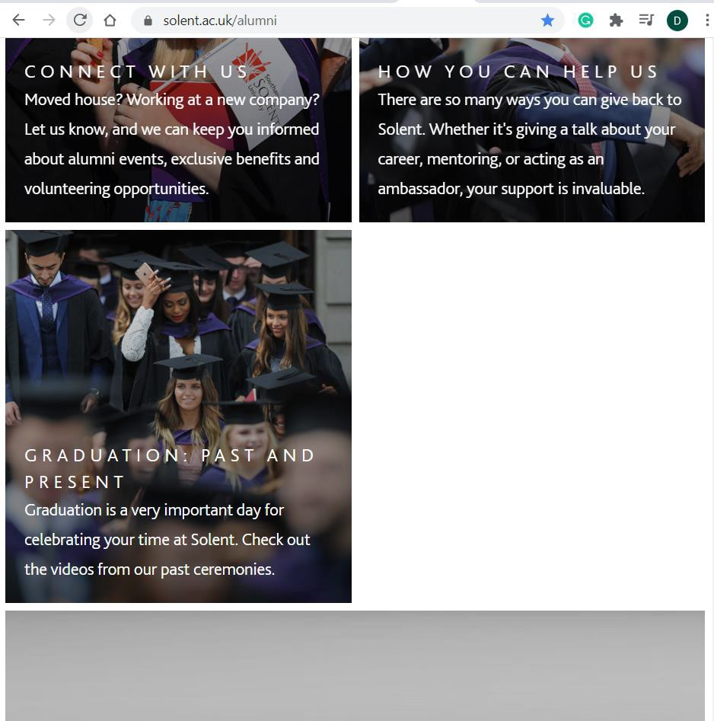

*Figure 1: Screenshot of Alumni website showing whitespace generated from medium screen size*

Further to this when completing the “update your details” form. The Married to a fellow alum section could dynamic show or hide based on the question “Married to a fellow alum?” which doesn’t have a related input.

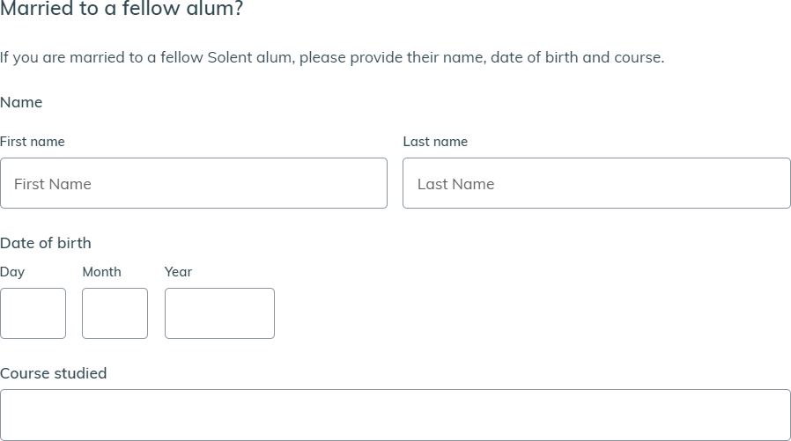

*Figure 2: Update your details form - proposed dynamic approach.*

Additionally, this forms also offers another issue in that it has 34 form fields that a potential user may need to complete. Birkett (2019) suggests that the best practice is to remove as many fields as possible in order to improve form completion rates. Additionally, Wroblewski (2018) highlights that web forms create a hurdle which can prevent a user and a business from achieving their goals, i.e. the user signing up.

## Solent University

### Mission and Vision

Solent University’s mission statement describes its pursuit to provide its learners with an education which enables them to be ready for their career and future. Solent’s vision aims to provide an exceptional experience for learners, provide learners with the skills to be ready for the future and to improve environmental sustainability (Solent University, n.d.b).

### Values

Solent University’s Values are Respect, Ownership, Inclusivity, Engagement, Integrity and Teamwork (Solent University, n.d.b).

### Features

The alumni website offers a number of benefits of its graduates which grant them free access or discounts on a range of products and services. The website also allows for graduates to request transcripts, references and certificates and provides a service for graduates to reconnect with lost friends. To aid the university the alumni website also allows for graduates to be able to share their story which can be used in promotion of the university,

allow graduates to volunteer their time to support current students and to make financial donations (Solent University n.d.a.).

## Market Research

When conducting market research I have compared Solent University with 3 other universities’ alumni websites (University of Surrey, University of Southampton and University of Exeter). The research conducted is given in Appendix A.

### Mission and Vision

All the universities reviewed have a similar mission statement which focuses on providing their students with an excellent education to provide a better future. Likewise for the vision, there is a common theme in improving the respective universities reputation and ensuring that students are successful.

### Values

The table below provides a summary of the values held by each university.

*Figure 3: Summary table of university values*

|  |  |  |  |  |
| --- | --- | --- | --- | --- |
| **Value** | **Solent**  **University** | **University of**  **Surrey** | **University of**  **Southampton** | **University of**  **Exeter** |
| Ambition |  | ✔️ |  |  |
| Community |  |  | ✔️ | ✔️ |
| Creativity |  |  | ✔️ |  |
| Engagement | ✔️ |  |  |  |
| Excellence |  | ✔️ | ✔️ | ✔️ |
| Inclusivity | ✔️ |  |  | ✔️ |
| Integrity | ✔️ | ✔️ | ✔️ |  |
| Ownership | ✔️ |  |  |  |
| Respect | ✔️ | ✔️ |  | ✔️ |
| Teamwork/  Collaboration | ✔️ | ✔️ |  |  |

Between the different universities there a lot of cross-overs with six of the ten values being held by more than one university. Solent was the only university to hold engagement and ownership as values, whilst multiple universities hold community and excellence as values where Solent doesn’t. Therefore the inclusion or exclusion fo these values should be considered when next reviewing Solent’s values.

### Features

The Features of each Alumni website have been recorded in Appendix A and summarised in the table below.

|  |  |  |  |  |
| --- | --- | --- | --- | --- |
| **Value** | **Solent**  **University** | **University of**  **Surrey** | **University of**  **Southampton** | **University of**  **Exeter** |
| Accommodation | ✔️ |  |  |  |
| Alumni Email Account |  |  | ✔️ |  |
| Careers Support | ✔️ | ✔️ | ✔️ | ✔️ |
| Cinema | ✔️ |  |  |  |
| Crowdfunding |  |  | ✔️ |  |
| Donations | ✔️ | ✔️ | ✔️ | ✔️ |
| Events/Networking/Lectures | ✔️ | ✔️ | ✔️ | ✔️ |
| Find lost friends/Reunion | ✔️ | ✔️ | ✔️ |  |
| Foreign Language Courses |  |  |  | ✔️ |
| Free Library Access | ✔️ | ✔️ | ✔️ | ✔️ |
| Gym discount | ✔️ | ✔️ | ✔️ |  |
| Magazine |  |  | ✔️ | ✔️ |
| Merchandise | ✔️ | ✔️ |  |  |
| Post-graduate discounts | ✔️ | ✔️ | ✔️ | ✔️ |
| Share your story | ✔️ | ✔️ |  |  |
| Shopping discounts |  | ✔️ |  | ✔️ |
| Students Union  Membership |  |  | ✔️ |  |
| Transcripts, References and  Certificates | ✔️ | Non-Alumni | Non-Alumni | Non-Alumni |
| Volunteer/Mentoring | ✔️ | ✔️ | ✔️ | ✔️ |

*Figure 4: Alumni website feature comparison table*

There are many features on the Alumni website which are common across all the universities reviewed, such as Careers Support, Events and Networking, Free Library Access, Post-graduate discounts, volunteering and making donations to the university. Replacement Transcripts and Certificates were available from each university, but only for Solent University was this included within the Alumni website. Share your story was promoted on the Solent and Surrey websites, however this opportunity may be promoted in the magazines offered by Southampton and Exeter.

The areas that Solent does not currently include in its Alumni offering are:

* + - * Alumni Email Accounts
      * Crowdfunding
      * Foreign Language Courses
      * Magazine
      * Shopping discounts
      * Students Union Membership

## Summary

From researching the Solent Alumni website, I have identified several areas which could be improved. These areas will be considered when designing the user research to identify the importance of these areas and the impact that this could have on the Alumni achieving its objectives.

Additionally, from the market research conducted, it is clear that Solent University is comparable with other universities, however, Solent University has some unique features of its alumni offer, such as its cinema and discounted accommodation. Additionally I believe that by including the replacement certificate and transcript service within the alumni website, this encourages users to also explore the other alumni benefits and services.

Lastly there are a number of features offered by other universities which should be considered for enhancing the Alumni offer.

# Essay 2 – User requirements

## User research

## User Journey

## Summary

# Essay 3 – Prototype and Testing

## Prototype

## Usability Testing

## Summary

# Conclusions and Recommendations

# References

BIRKETT, A., 2019. *Form Design: 13 Empirically Backed Best Practices* [viewed 2/11/ 2021]. Available from: <https://cxl.com/blog/form-design-best-practices/>

KOPROWSKI, E., 2016. *Four Reasons to Get Involved With Alumni Associations* [viewed 02/11/ 2021]. Available from: <https://www.masterstudies.com/article/Four-Reasons-to-Get-Involved-With-Alumni-Associations/>

MAIOLI, L., 2018. *Fixing Bad UX Designs Master Proven Approaches, Tools, and Techniques to Make Your User Experience Great Again.* Packt Publishing

SOLENT UNIVERSITY, n.d.a. *Alumni* [viewed 2/11/ 2021]. Available from: <https://www.solent.ac.uk/alumni> SOLENT UNIVERSITY, n.d.b. *Solent University Strategy 2025* [viewed 2/11/ 2021]. Available

from: <https://www.solent.ac.uk/strategy-2025/welcome>

WROBLEWSKI, L., 2008. *Web Form Design Filling in the Blanks.* Rosenfeld Media YABLONSKI, J., 2020. *Laws of UX*

*Using Psychology to Design Better Products & Services.* O'Reilly Media, Incorporated

# Bibliography

BERA, 2021. *BERA* [viewed 02/11/ 2021]. Available from: <https://www.bera.ac.uk/>

BISHOP, R., 2020. *Why Alumni Are Important for Higher Ed Institutions* [viewed 02/11/ 2021]. Available from: <https://www.signalvine.com/alumni/why-alumni-are-important-for-higher-ed-institutions>

MARCONI, M., 2021. *The future of customer experience needs to be frictionless* [viewed 02/11/ 2021]. Available from: <https://www.wired.co.uk/bc/article/retail-friction>

UNIVERSITY OF EXETER, n.d.a. *Alumni and Supporters* [viewed 02/11/ 2021]. Available from: <https://www.exeter.ac.uk/alumnisupporters/>

UNIVERSITY OF EXETER, n.d.b. *Strategy 2030* [viewed 02/11/ 2021]. Available from: <https://www.exeter.ac.uk/strategy2030/>

UNIVERSITY OF SOUTHAMPTON, 2021a. *Alumni and Supporters* [viewed 02/11/ 2021]. Available from: <https://www.southampton.ac.uk/alumni-supporters.page>

UNIVERSITY OF SOUTHAMPTON, 2021b. *The University strategy* [viewed 02/11/ 2021]. Available from: <https://www.southampton.ac.uk/about/strategy.page>

UNIVERSITY OF SURREY, 2017. *The Surrey Advantage Corporate Strategy 2017-2022* [viewed 02/11/ 2021]. Available from: <https://www.surrey.ac.uk/sites/default/files/corporate-strategy-2017-2022.pdf>

UNIVERSITY OF SURREY, n.d. *Alumni and friends* [viewed 02/11/ 2021]. Available from: <https://www.surrey.ac.uk/alumni>

# Learning Outcomes Self-Assessment

*(LOs – mapped for each of the 3 sections. Evidence all 5 are addressed.) What you will be able to do after the module: Use the key words of the LOs.*

|  |  |  |
| --- | --- | --- |
| **Module Learning Outcome** | **Evidence (Section #) / Notes** | **Personal Learning Outcome** |
| 1. Implement problem solving techniques into designing features and functionalities to produce industry level products. |  |  |
| 2. Compare User Experience principles to accommodate different forms of interaction across multiple touchpoints (physical and/or digital), and to formulate and apply these principles in complex contexts. |  |  |
| 3. Analyse proposed UX design solutions using a range of methodologies and techniques against goals, objectives and key performance indicators (KPIs). |  |  |
| 4. Critically evaluate and validate solutions against goals, objectives and key performance indicators (KPIs) with a view to continuous improvement of the digital product or service. |  |  |
| 5. Apply accessibility principles to digital product design. |  |  |

# Appendices

# Appendix A – Market Research

|  |  |  |  |  |
| --- | --- | --- | --- | --- |
| **University** | Solent University | University of Surrey | University of Southampton | University of Exeter |
| **Mission Statement** | To enable our learners to be work- ready, world-ready and future-ready. | The University of Surrey provides excellent education, and advances and disseminates knowledge.  The University transforms lives and shapes the world for a better future by partnering with students, governments, businesses, alumni and local communities.The University makes social and economic impacts through research and innovation, and provides solutions to global challenges. | Our mission: to change the world for the better  The University of Southampton is an exceptional place whose people achieve remarkable things. We are a world-leading, research-intensive university, with a strong educational offering, renowned for our innovation and enterprise. This is a great platform from which to sharpen our focus with our new strategy.  It’s a very simple strategy. It’s about our aspirations. It’s about building our reputation. It’s about being simply better than our competitors at what  we do. | To use the power of our education and research to create a sustainable, healthy and socially just future. |
| **Vision** | By 2025 we will enable students to succeed by being a university that:  Transforms the lives of people from all backgrounds, through learning that is relevant to the real world.  Provides an outstanding student experience through our exceptional staff and facilities. Excels at providing its learning community with the confidence, skills, knowledge and experience they need to successfully pursue fulfilling lives and life-changing careers.  Delivers a unique curriculum | The University of Surrey will be a leading global university.  We will be renowned for the outstanding quality and impact of our graduates and research, as well as our collective contributions to society.  We will build on our distinctive heritage of practice-based learning and excellent student experience, and embrace our future by focusing on digital transformation. | We will develop graduates who are confident global citizens, equipped to make a positive contribution to the world. Our knowledge and technologies, developed through our research and applied through our enterprise, will have real economic and social benefit for the world.  People will choose Southampton because of its reputation for quality and to play a part in changing the world. Our staff will say it is a great place to work, where they are encouraged to be  creative and are part of a team | In order to achieve our purpose, in the next decade we will build on our strong interdisciplinary culture to:  Lead meaningful action against the climate emergency and ecological crisis.  Make key breakthroughs to transform human health and wellbeing.  Lead the progress towards creating a fair, socially just and inclusive  society. |

|  |  |  |  |  |
| --- | --- | --- | --- | --- |
| **University** | Solent University | University of Surrey | University of Southampton | University of Exeter |
|  | shaped around inspiring industrial partnerships, ground-breaking professional insights, knowledge exchange, and research.  Makes a material impact on environmental sustainability. |  | that achieves more together.  We will be a university consistently ranked in the top 10 nationally and top 100 internationally. Our student satisfaction will be among the highest in the country, reflected in the National Student Survey (NSS). Our graduate prospects will be among the best. Our entry tariff will reflect our reputation as a leading university, with completion rates and good degrees reflecting our commitment to fully developing the potential of our students.  Our world-leading research will underpin an excellent Research Excellence Framework (REF) position. We will achieve all of this while improving our sustainability and generating a surplus that allows us to invest in our  University. |  |
| **Values** | Respect Ownership Inclusivity Engagement Integrity  Teamwork | Respect Ambition Collaboration Integrity Excellence | Excellence Creativity Community Integrity | Discovery Respect Excellence Inclusion Community |
| **Features of Alumni Website** | Help you   * Events * Discount on postgraduate study * Discount gym prices | Support   * Networking * Mentoring   Benefits | Benefits   * Events * Networking * Careers Support | Community   * Networking and groups * Alumni events * magazine/newsletter |

|  |  |  |  |  |
| --- | --- | --- | --- | --- |
| **University** | Solent University | University of Surrey | University of Southampton | University of Exeter |
|  | * Careers Support * Free Library Access * Accomodation * Sonar Film (Cinema) * Transcripts, References and Certificates * Merchandise * Find lost friends Help us * Share your story * Volunteer your time * Dontations | * Careers advice * Discount on postgraduate courses * shopping discounts * Library access * Sport membership discount * Merchandise Sharing stories Organise a reunion Donations   Leave money in your will Volunteering | * Magazine * Mentoring * Access to Campus facilities * Free Alumni Email Account * Find a friend service * Discount on post graduate courses * discount on Sport and Wellbeing membership * Students Union Membership Support the university * Volunteering * Giving a gift * Crowdfunding | Benefits   * Discounts from a range of companies * Careers Support * Postgraduate discounts * Library Access and Online resources * Lectures * Foregin Language Evening Cources   Support us   * Volunteering * Donate * Leaving money in your will |